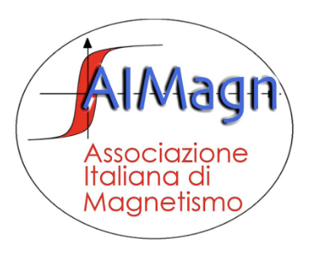
VIII Italian Conference on Magnetism
Milan, 7-9 February 2024

MAGNET 2024 Registration & AIMagn Association Form

Surname: _____________________________ Name: _______________________________
Place of birth: __________________________ Date of birth: _________________________
Fiscal code/VAT number: __________________________________________________________
Email: _________________________________________________________________________
Affiliation: ______________________________________________________________________
Address: _______________________________________________________________________
Current Position: _________________________________________________________________
Research field: ___________________________________________________________________

Indicate items required in the table below:
 | Early Registration  (up to 12/01/2024) |  | Late Registration  (after 12/01/2024)
Regular (Includes AIMagn membership 2024) | 240 € | ⎕ | 290 € | ⎕
Student * (Includes AIMagn membership 2024) | 170 € | ⎕ | 220 € | ⎕
Social Dinner § (Participant) | 50 € | ⎕ | 50 € | ⎕
Social Dinner § (Accompanying person) | 65 € | ⎕ | 65 € | ⎕
* Students and early-stage researchers not having yet discussed their own PhD thesis are entitled to this category. Certificate proving the student status is required.
§ Social Dinner at the Restaurant El Brellin, Milano – Please detail any food restriction (eg. vegetarian), allergies, and special needs: _________________________________________________
_______________________________________________________________________________

Payment of the registration fee can only be made by bank transfer to Associazione Italiana di Magnetismo:
IBAN: IT37G0200812710000101395051
BIC/SWIFT: UNCRITMMXXX

Place/Date Signature

